

#### HUMAN BIOLOGICAL SCIENCES STAGE 2

## **CIRCULATORY SYSTEM**

**EXTENDED RESPONSE**

Name: ___________________________________

1. The diagram below schematically represents the blood flow into and out of the heart.

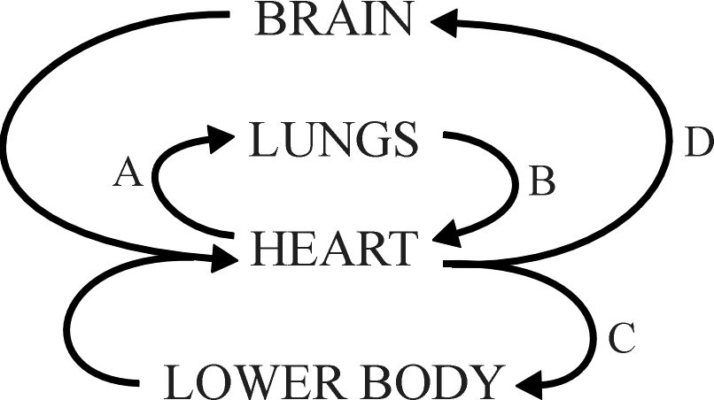

1. Blood taken from which part of the circulatory system (A, B, C of D) would have the highest concentration of carbon dioxide. [1]
2. Name blood vessel B. [1]
3. Name the major blood vessel from which C and D branch. [1]
4. Complete the missing labels on the heart diagram below. [3]

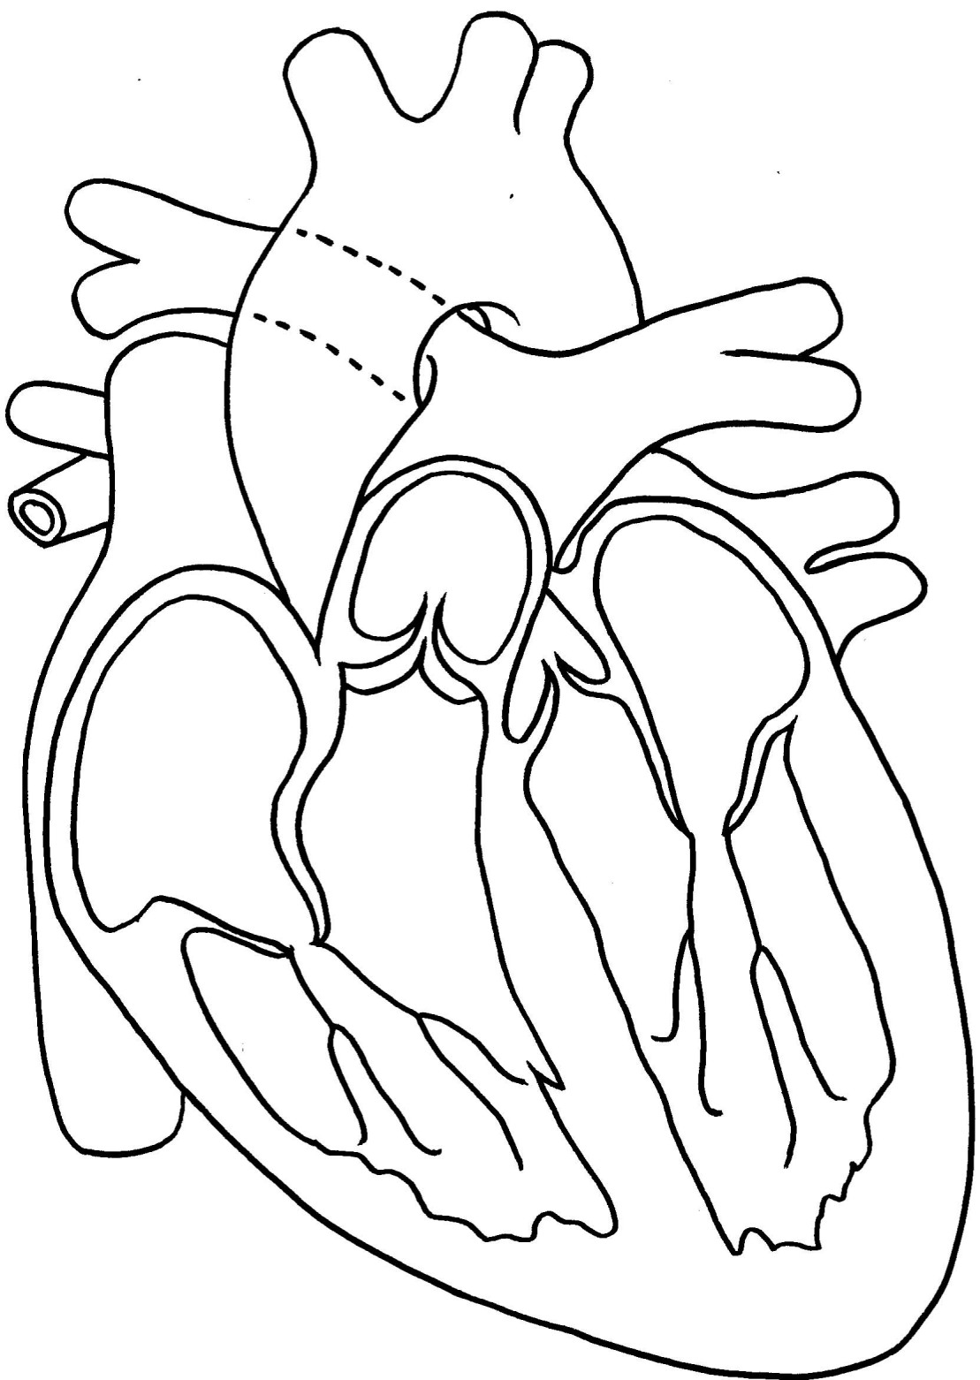

Valve

Chamber

Blood vessel

1. The diagram below shows the internal structure of a normal and a diseased artery.

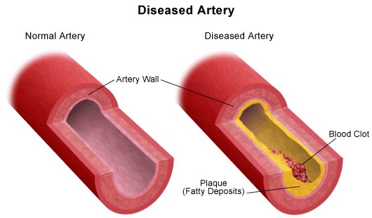

* 1. Describe two ways in which the wall of a normal artery is different to the wall of a vein. [2]
  2. For each of the statements listed below circle whether it is true or false. [2]

1. Atherosclerosis is characterised by the formation

of plaque on the internal walls of arteries. T F

1. The formation of plaques increases the risk of

hypertension. T F

1. Smoking is one of the main risk factors for plaque

formation. T F

1. A stroke is caused when an artery supplying blood to

the heart is blocked. T F

1. Electrocardiograms can be used to measure heart rate and analyse the functioning of the heart.
   1. There are three main parts to an ECG – P-wave, QRS complex and T-wave. Label these parts on the ECG below. [1]

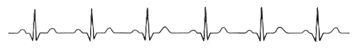

* 1. What is happening in the heart when each of these waves is formed? [3]
  2. Why is the P wave so much smaller than the QRS complex? [1]
  3. If the ECG trace above was taken over a period of 4 seconds, what was the person’s heart rate? [1]

1. Blood pressure in arteries is measured using an instrument called a sphygmomanometer. Explain in detail how you would use this instrument to measure blood pressure. Your answer should include information on the meaning of systolic and diastolic pressure. [5]
2. Consider the following graph:

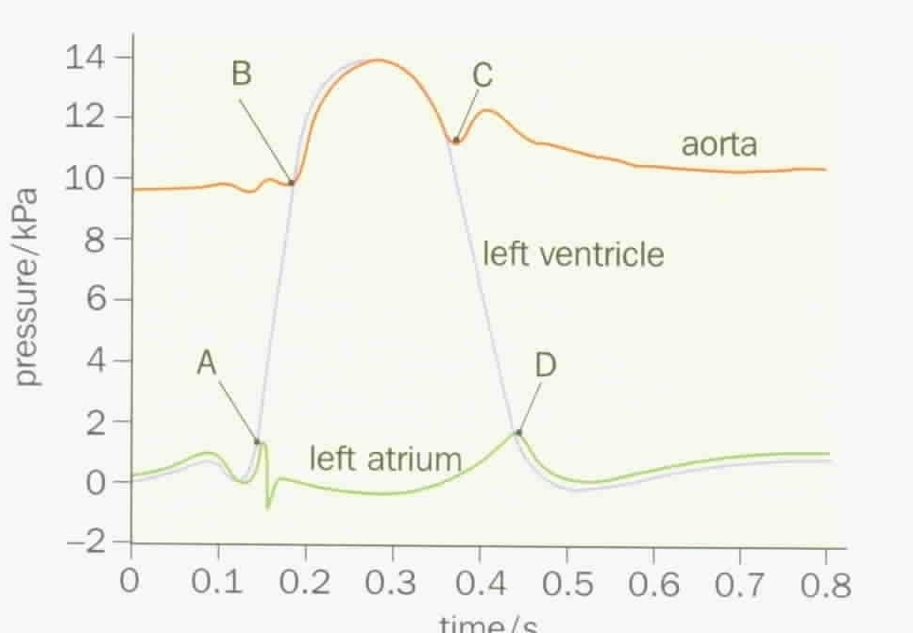

* 1. At point A the pressure in the left ventricle starts to exceed the pressure of the left atrium. What effect would this have on the left atrioventricular valve? [1]

* 1. At point B the pressure of the left ventricle starts to exceed the pressure of the aorta. What effect would this have on the aortic valve? [1]

6. Below is an image of a blood smear taken through a light microscope.

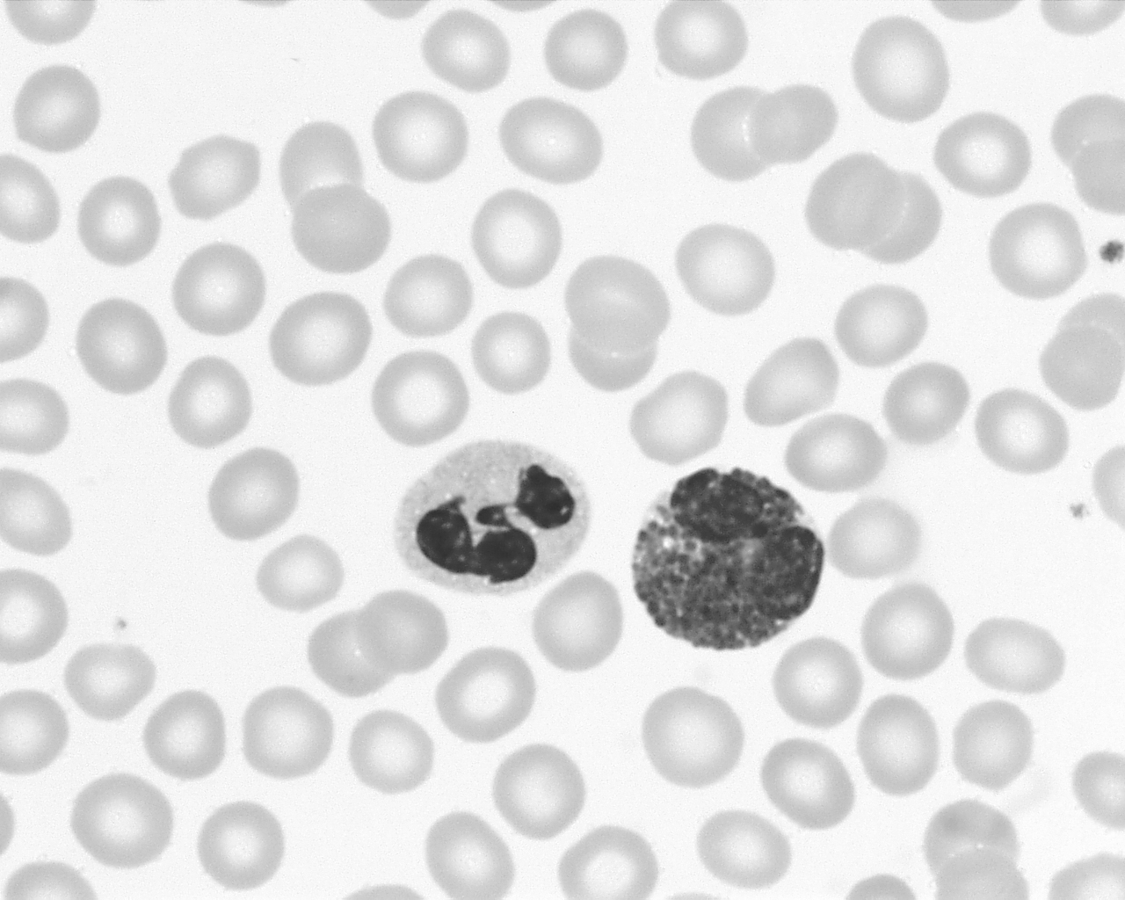

The cell identified by the arrow is a red blood cell.

1. Give two structural features of this cell that distinguish it from the two white blood cells. [2]
2. Platelets are not easily identified in this image. Describe the function of platelets? [1]

**END of ASSESSMENT**